DSCI 5350 Activity 1

Activity 1: Understanding Linux and Hadoop commands

Satya Sriharsha Buddha

Command: pwd

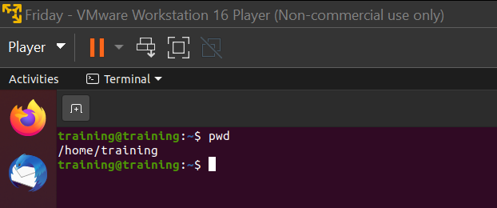

Command: ls  
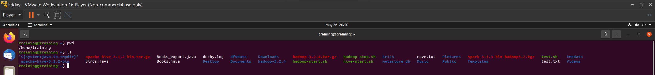

Command: ls –l

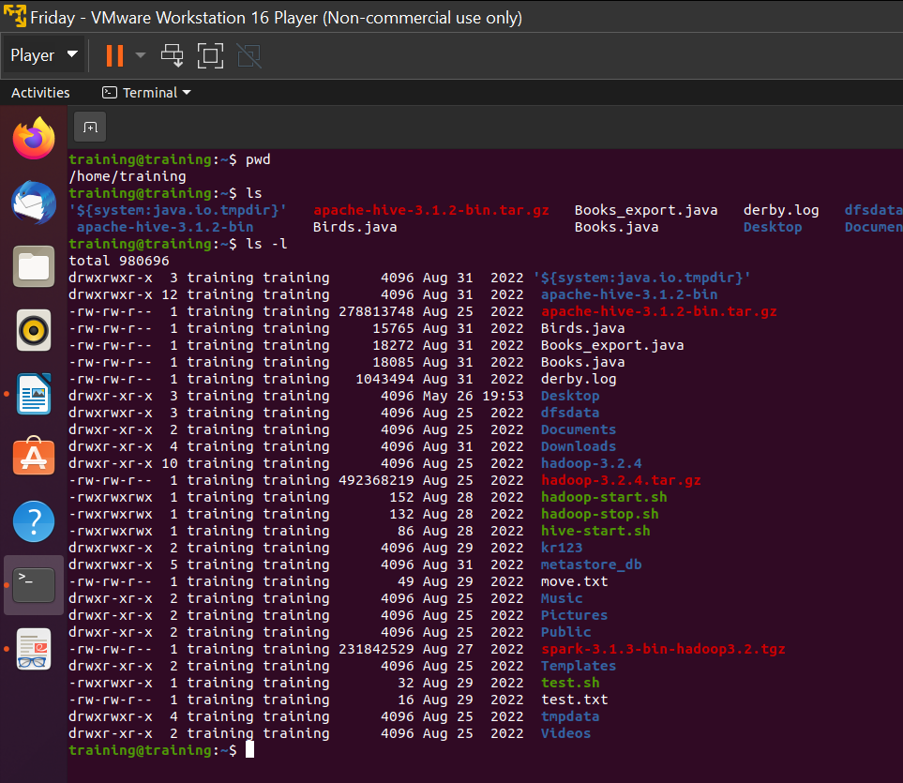

Command: cd  
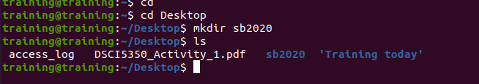

Command: mkdir & rmdir



Command: rm  


Command: touch  
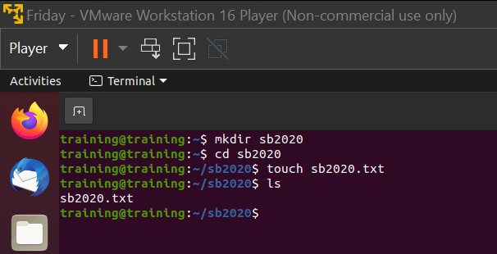

Command : cp --help  
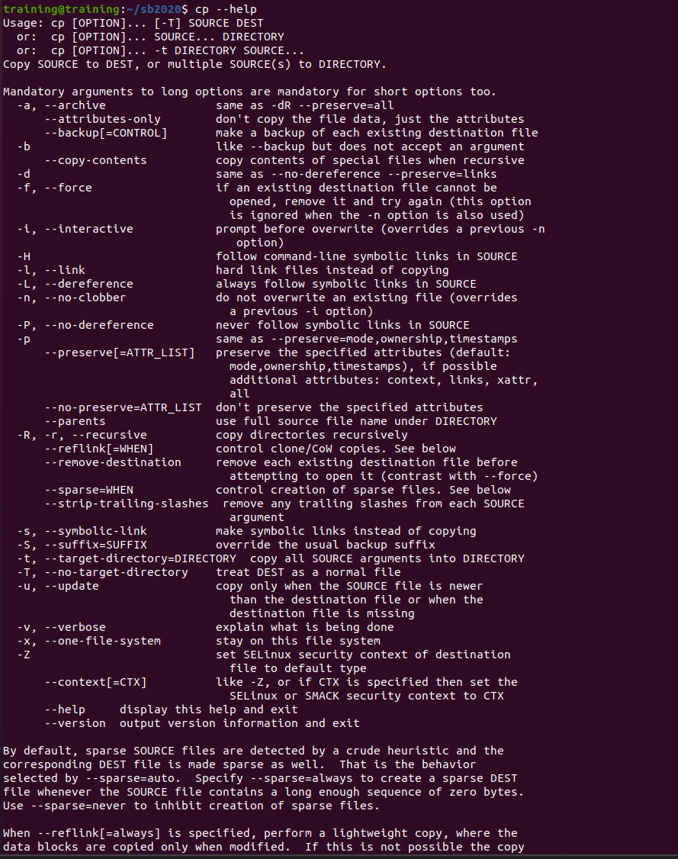

Command: cp



Command: mv



Command: echo and Command: cat  
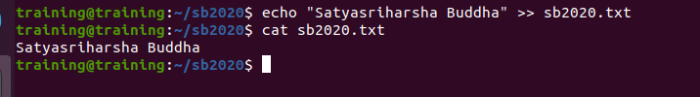

Command: nano, vi  
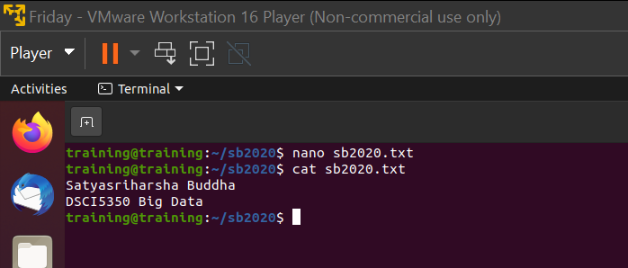

Command: sudo  
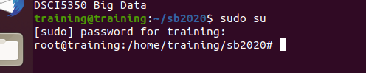

Command: df and df -m  
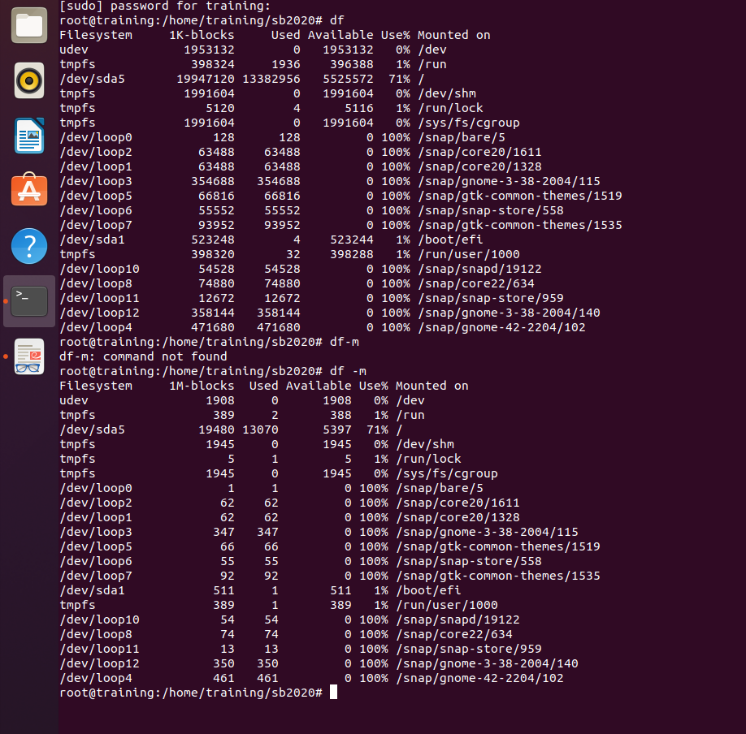

Command: chmod

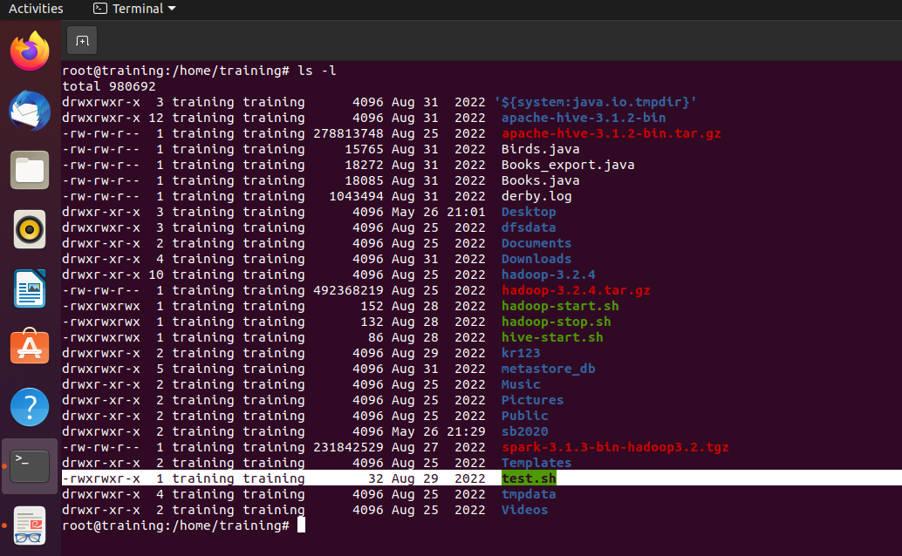

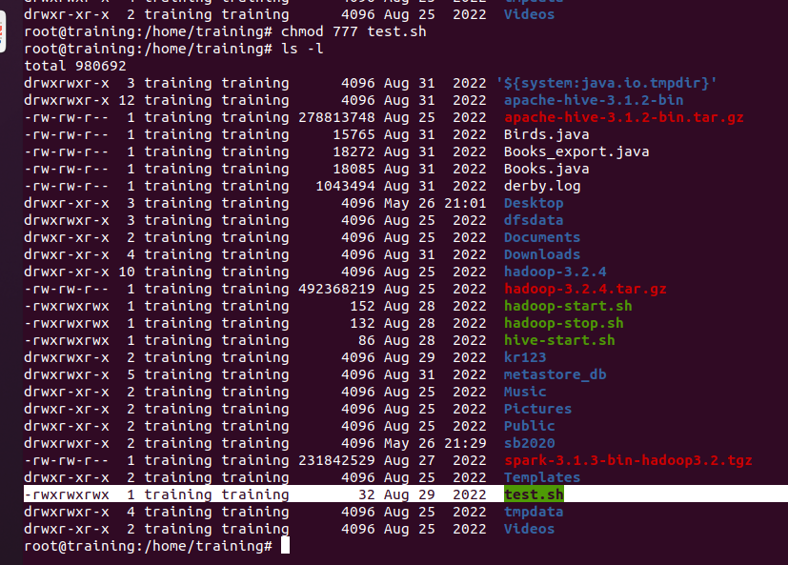

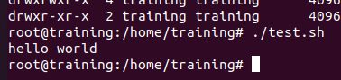

Command: Clear



Command: free  
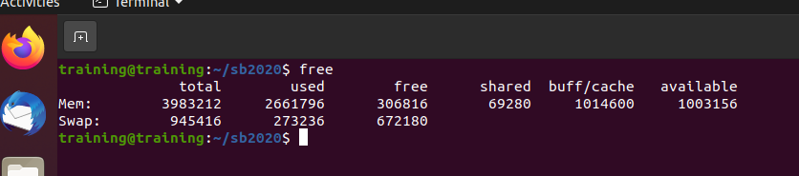

Hadoop Commands

Commands: cd $HADOOP_HOME/sbin  
start-dfs.sh  
start-yarn.sh

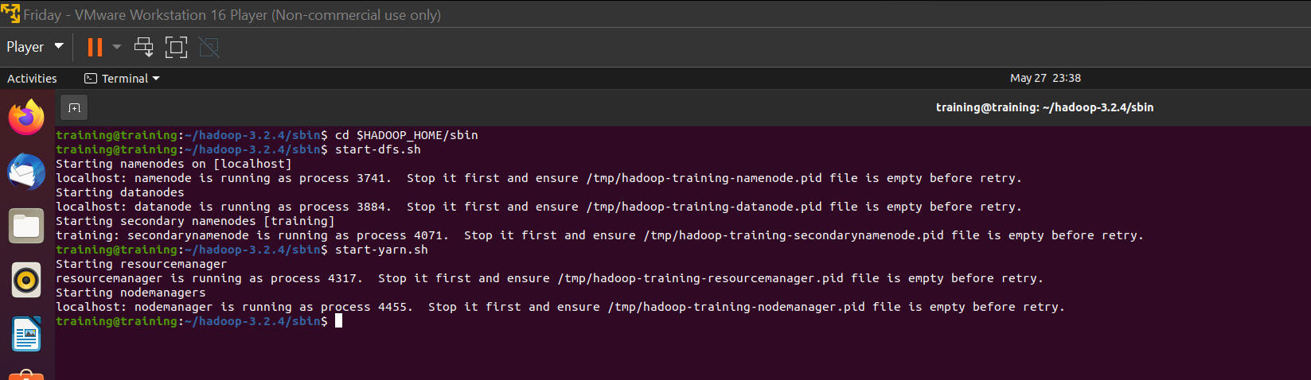

Command: hadoop-start.sh

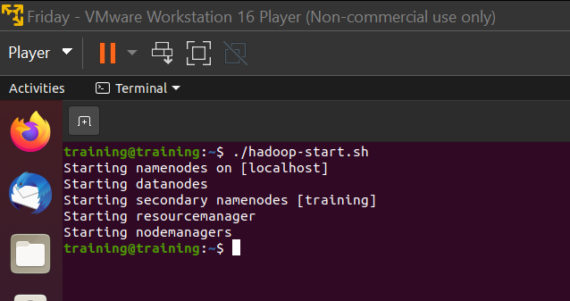

Command: jps  
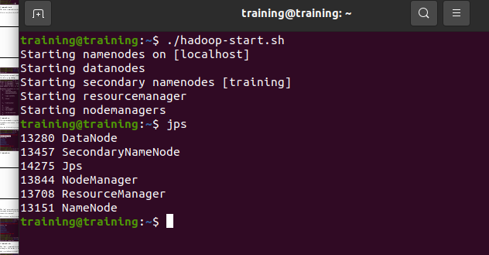

Command: hdfs dfs  
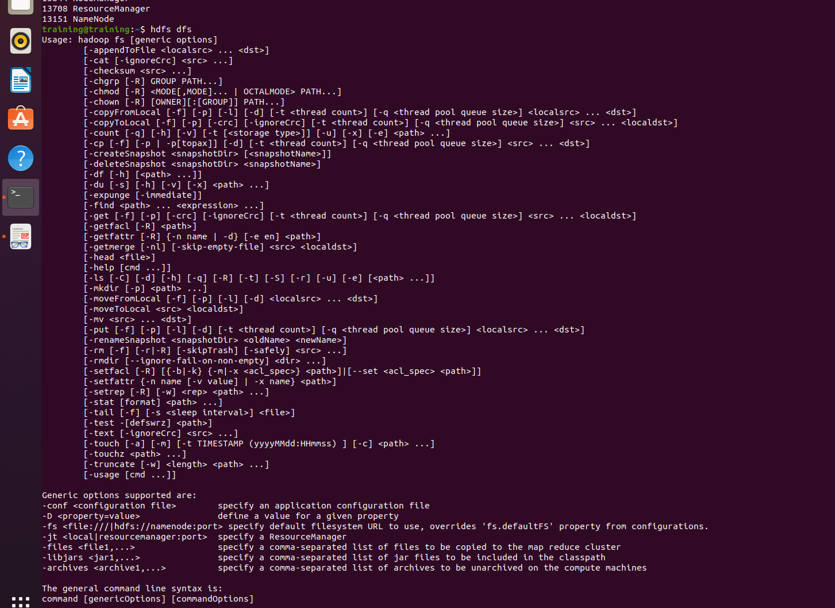

Command: hdfs dfs -ls /

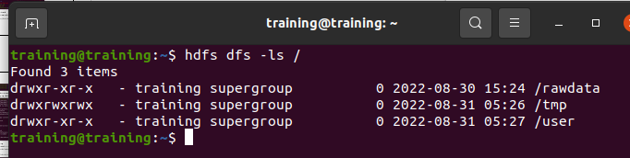

Command: hdfs dfs –mkdir



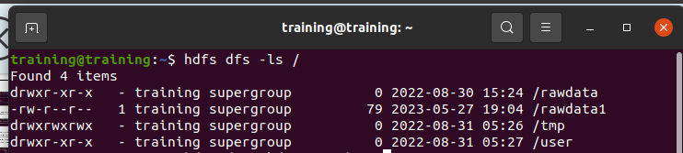

Command: hdfs dfs -put Desktop/access_log /rawdata



Command: hdfs dfs -ls /rawdata

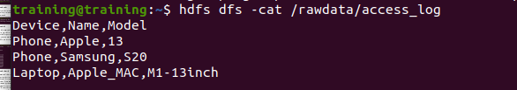

Command : ./hadoop-stop.sh  
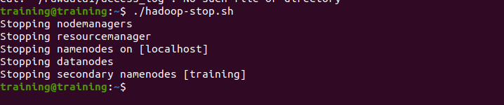

Exploration:

We can move 2 or more files at a time using the mv command

Here we moved Music and Pictures from Home to Desktop

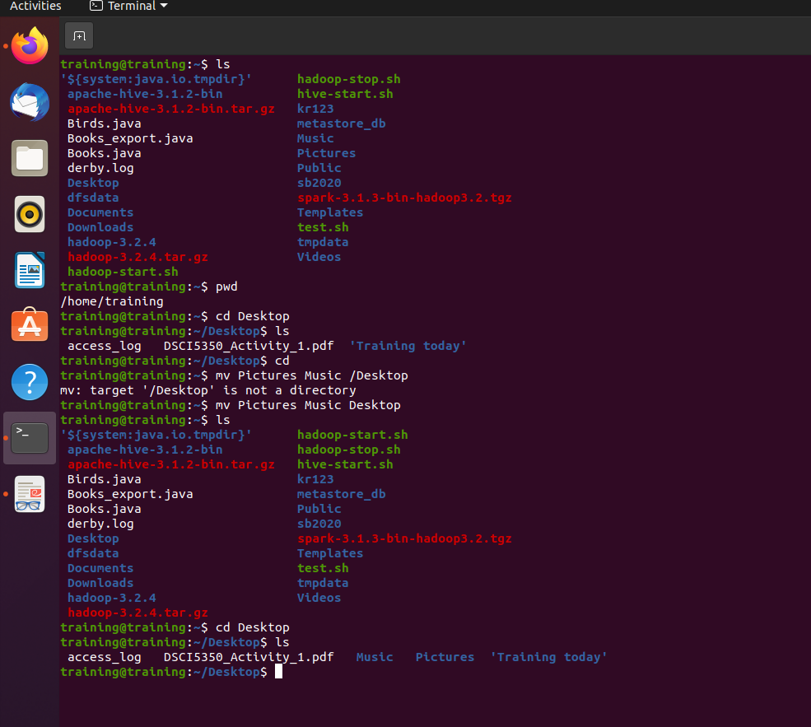

Editing a file using Vi command

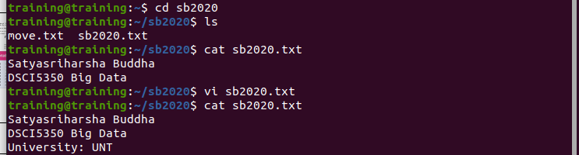

Command: copyFromLocal

